Website: https://fyp-gc.uestc.edu.cn/

For supervisor：
1、Go to the dropdown menu and follow the operations as shown in the diagram.
Click “Fill in"
Click on the menu to access the Distribute Task Sheet and Work Plan
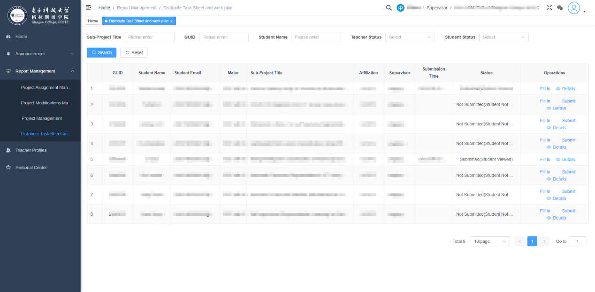
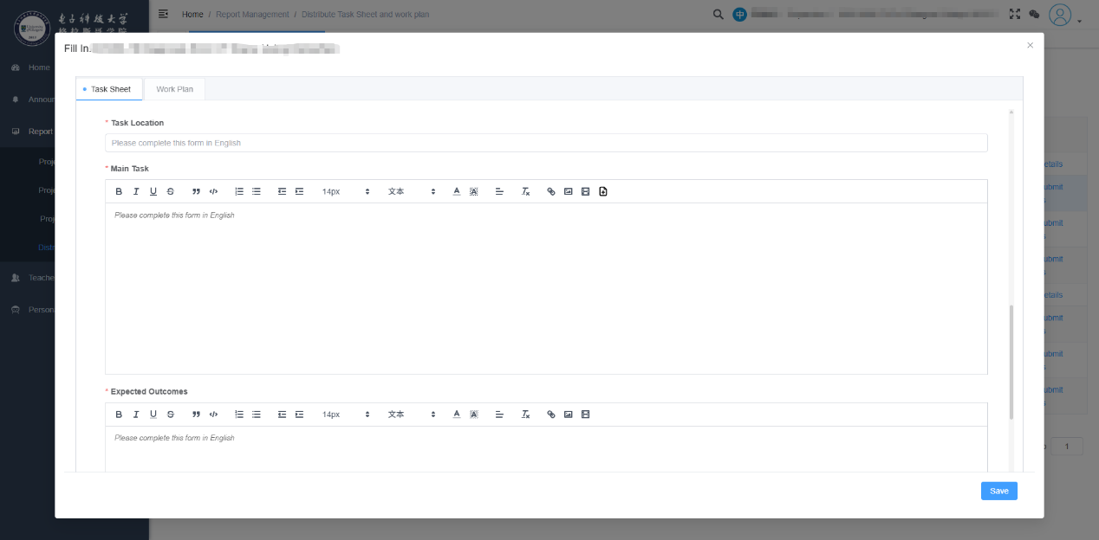
2、Fill in the task sheet and click "Save".
4.Save
3.Fill in the "Main Task" section

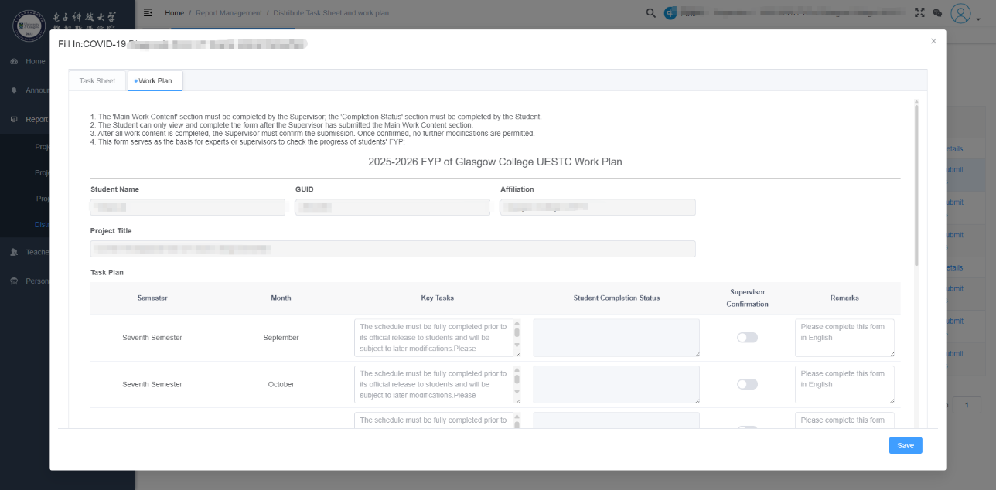
3、Fill in the plan form and click "Save". Please fill in the information for the entire year.
6.Save
5.Fill in the FYP work plan
4、After filling out the task sheet and the plan form, submit the task form and the plan form.
7.Click “Submit”
“
5、Supervisors are expected to confirm after students have filled in the "Student Completion Status" section.
